Visa Application Procedure
- Send email of visa procedure to parents in April/May
Email template : Filing system_Visa_2018 Visa application procedure
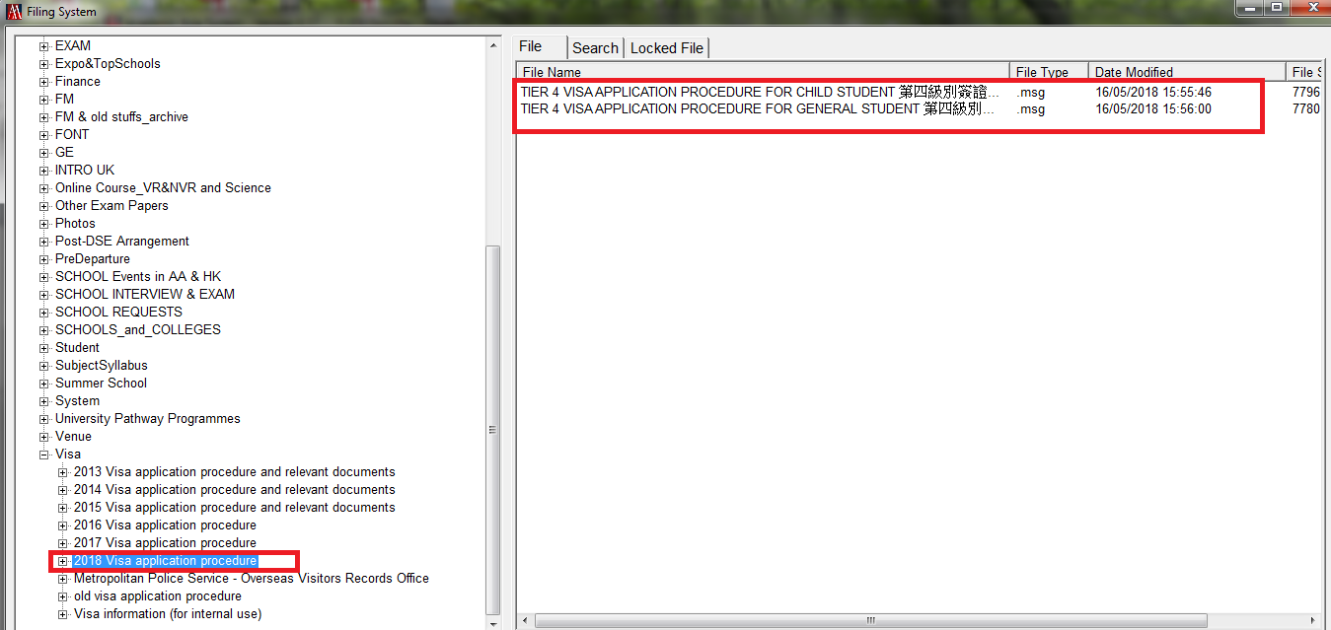
- Send CAS statement by email to Parents and update visa status in the visa page
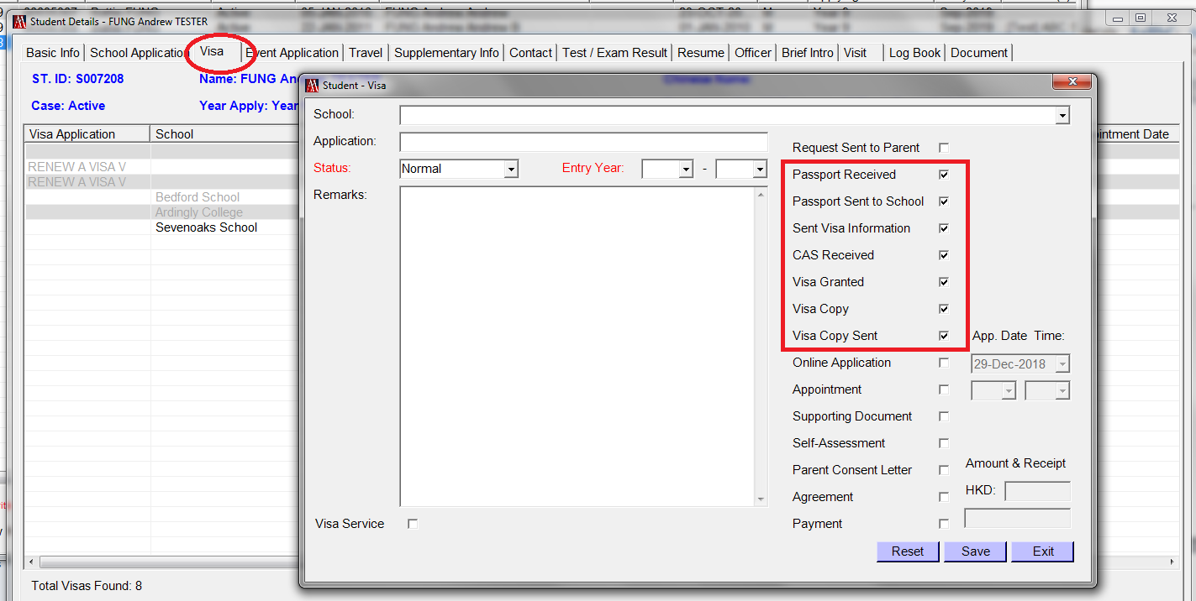

Visa Service Procedure :

  - Ask Parents to give the following details if they need to use visa service.
- student’s all old passports detail
- All old passports and travelling history
- Current passport and travelling history
- Parents’ detail – parents’ full name, date of birth and nationality
- When you wish to travel to the UK
- Has student been to the UK before, if yes, please provide
- Date of visa (MM/YEAR) and how long was the visit ___________
(please provide details of up to your 2 most recent visits)
- How long has student been living in the current home address?

- Make online application and prepare visa documents after receiving all information from parents, and mark down the login email address and password in the VISA page.
Please refer to the Template 2 – online applicaton (page 28 – 98) of Tier 4 visa application procedure for Child students for details.
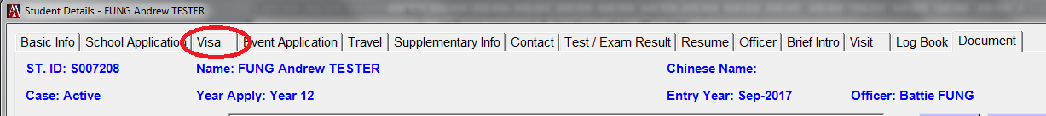
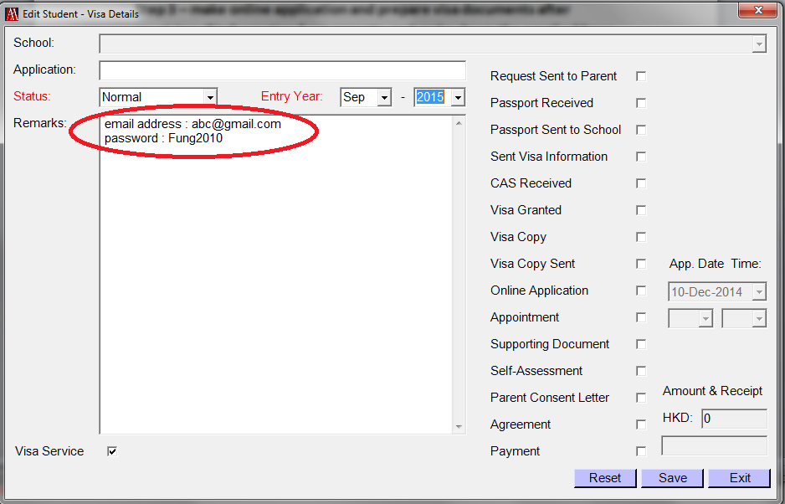
- Organize checklist of supporting documents to parents
Please refer to the step 5.10_checklist (page 14) of Tier 4 visa application procedure for Child student for details
- Mark down the visa appointment date and put “√” in the relevant box in the VISA page
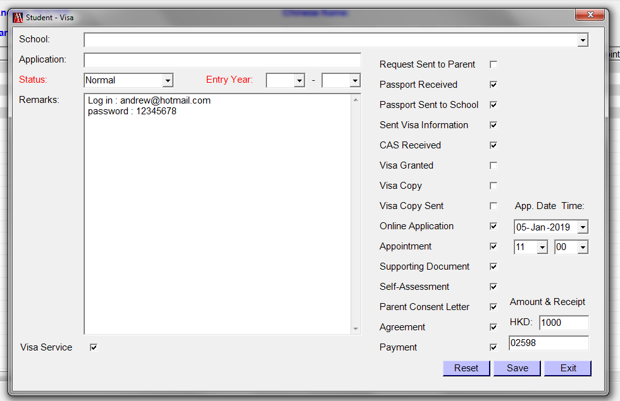

- Save the completed online application and all visa documents in the DOCUMENT page
